SCHEMATIC:

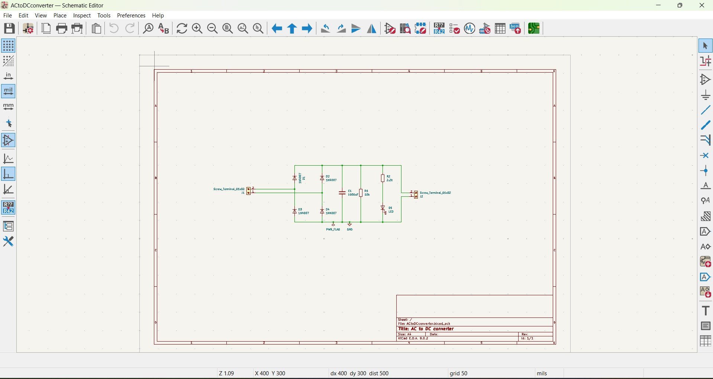

In the above circuit, DC voltage is applied through the input screw terminal J1, which then passes through four diodes D1–D4 (1N4007) arranged in a bridge rectifier configuration. The bridge rectifier converts the alternating current into pulsating DC by allowing both halves of the AC waveform to flow in the same direction. The output from the rectifier is then smoothed by the capacitor (C1), which reduces ripple and produces a more stable DC voltage. The 10 kΩ resistor (R1) acts as a bleeder resistor, helping discharge the capacitor when power is turned off and stabilizing the circuit. An LED (D5) along with a resistor (R2) serves as a power indicator, lighting up when DC output is present while the resistor limits current through the LED. Finally, the filtered DC output is available at the screw terminal J2, providing a usable DC supply for other circuits.

FOOTPRINTS ASSIGNED:



ROUTED PCB:

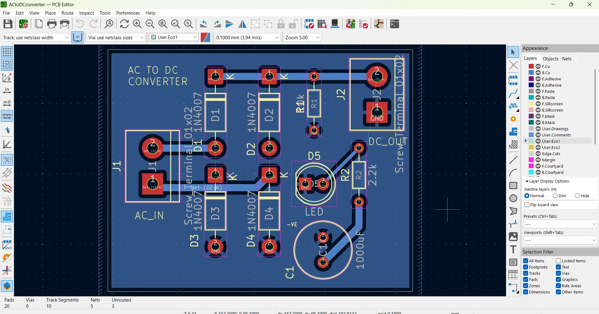

Two-layer PCB design – Uses top and bottom copper layers for routing connections efficiently.
Thick power traces – DC power lines are made thicker to handle higher current and reduce voltage drop.
Logical component placement – AC input, rectifier diodes, filter capacitor, and DC output are arranged in proper signal flow order.
Bridge rectifier layout – Four diodes are positioned to easily form the full-wave rectifier.

